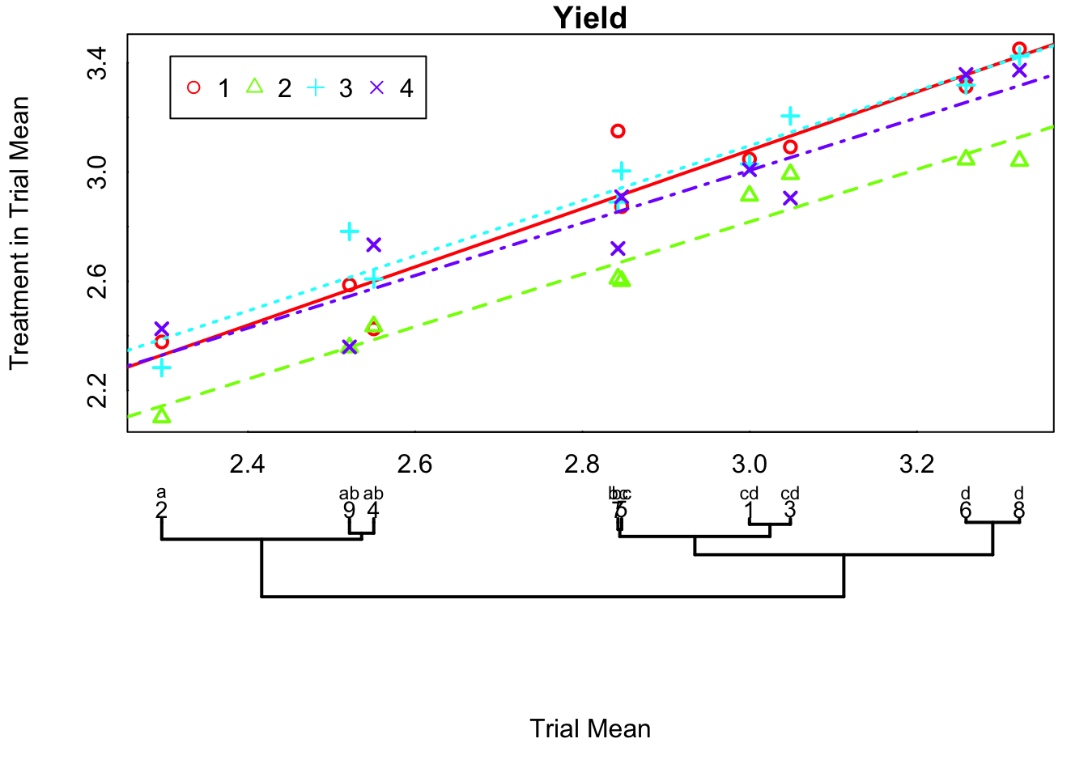
By including compact letter display, we can include visual indication of significance based on trial means and error derived from REML models.
Alternatively we can include horizontal lines.

